**UNIT- 3**

**SYNCHRONOUS SEQUENTIAL LOGIC**

**PART-A**

1. Derive the characteristic equation for JK and T Flip-flops
2. Differentiate between sequential and combinational circuits
3. What is race around condition?
4. Draw the timing diagram showing the output of a two stage synchronous counter with respect to its clock signal.
5. Differentiate flip flop from latches
6. Draw the excitation table and state diagram for JK and SR flip flops
7. Realize JK flip flop using D flip flop and gates
8. Write HDL code for up-down counter using behavioural model
9. Differentiate Moore and Mealy circuit model
10. What is a shift register? Write the applications of a shift register.

**PART-B**

1. **Perform the following conversions. i) SR flip-flop to T flip-flop**

**ii) T flip-flop to D flip-flop.**

Ans. **i) SR flip-flop to T flip-flop**

Firstly write the truth table for SR to T flip-flop as shown:

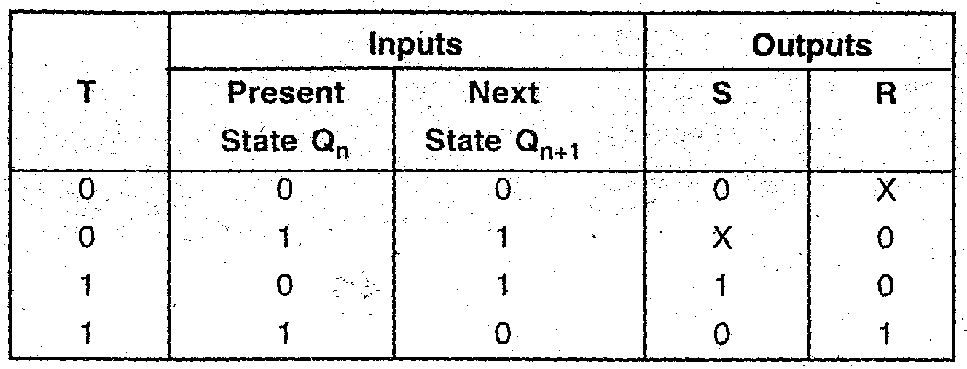

 K maps for S & R are:

For S:                                                                      For R:

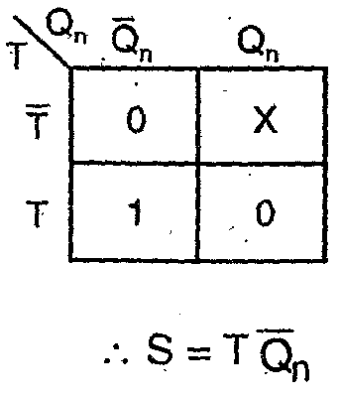                                                    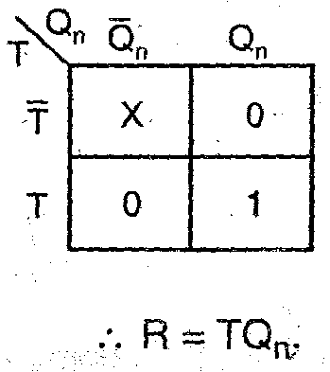

Implementation:

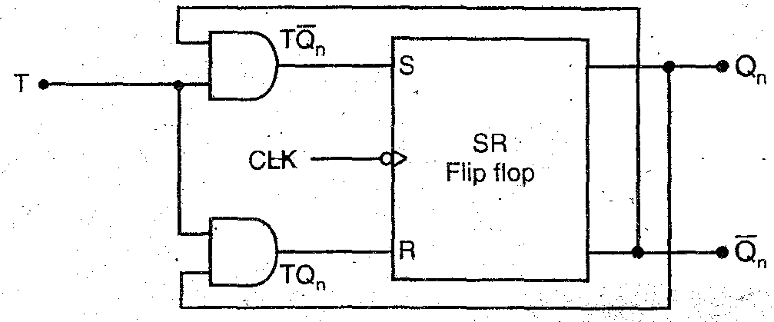

**ii) T flip-flop to D flip-flop.**

  Truth table for conversion:

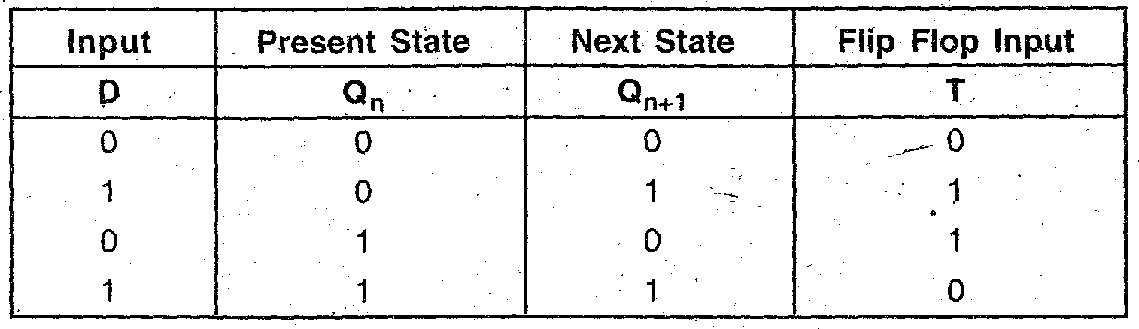

 K-map for T: Implementation of circuit diagram:

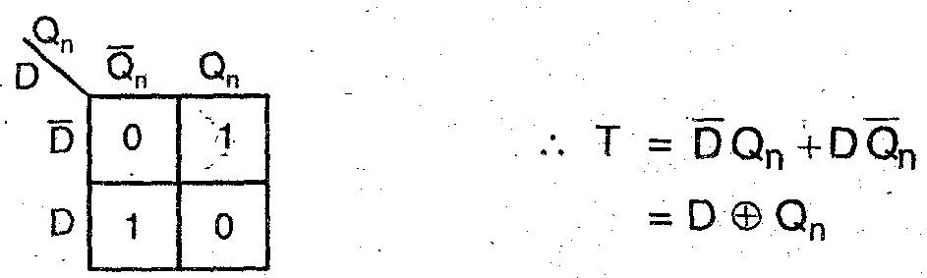     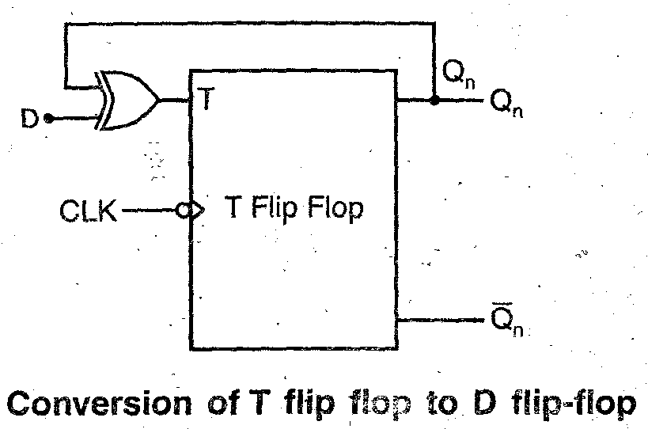

1. **For the given state diagram, draw the state reduction diagram.**

**Stats Diagram:**

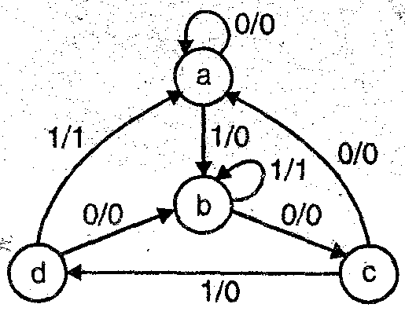

**Ans. State table is as shown:**

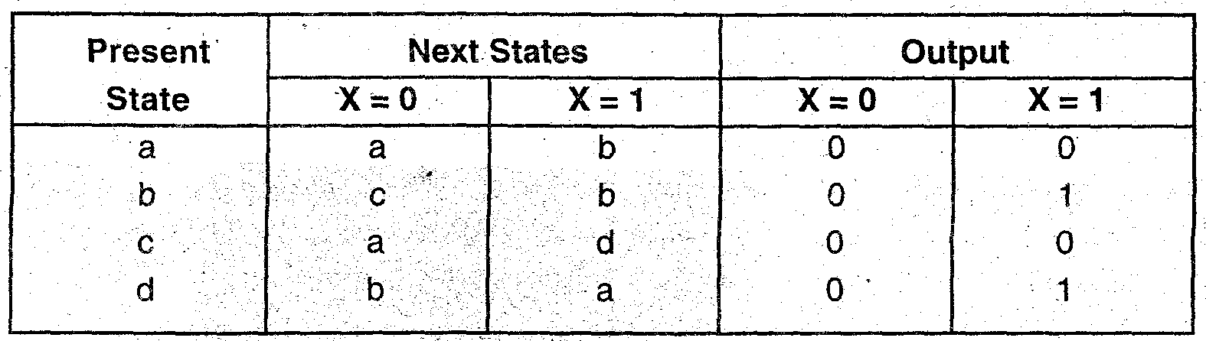

**For modified reduced state diagram:**

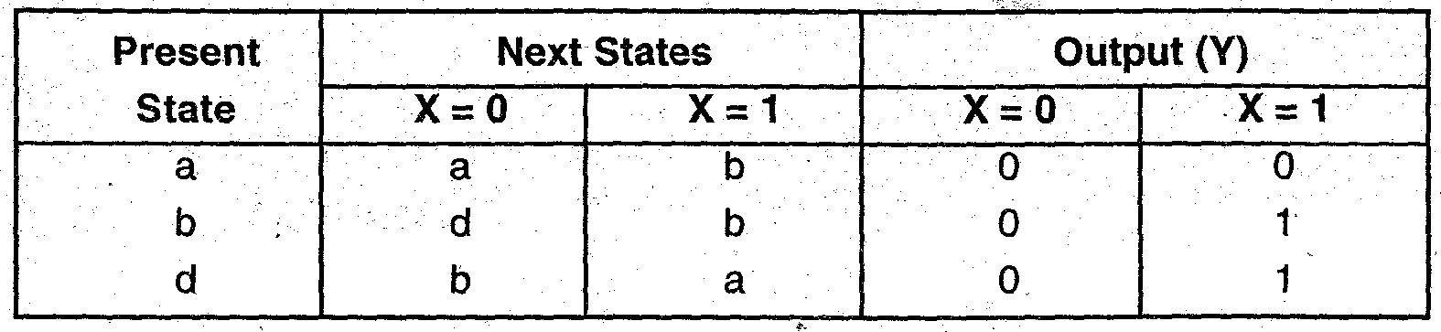

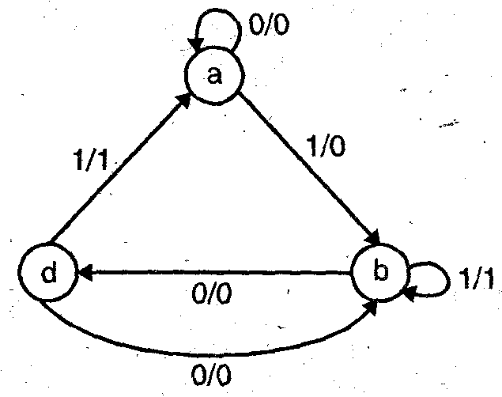

**3. Draw a master-slave J-K flip-flop system. Explain its operation and show that the race-around condition is eliminated.**

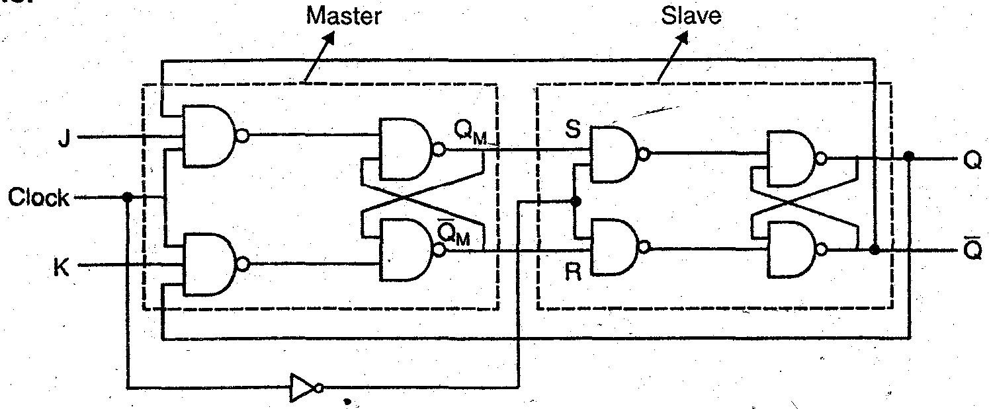

**A master-slave J-K flip-flop is constructed from two flip-flops. One flip-flop acts as a master and the other as a slave and the overall circuit is thus, called as master-slave flip-flop. It make use of J-K master flip-flop and S-A slave flip-flop. The master is positive edge triggered and slave is negative edge triggered. Therefore, master responds to J-K inputs before the slave. V**

**If J = 1 and K = 0, the master sets on the positive clock edge. The high output of the master drives the J input of the slave, so when the negative clock edge arrives, the slave sets, copying the action of the master.**

**If J = 0 and K = 1, the master resets on the positive clock edge. The high output of master i.e. 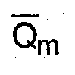 goes to R input of the slave. Therefore, slave resets on arrival of negative clock edge.**

**If J = K = 1 for master, it toggles on positive clock edge and the slave them toggles on the negative clock edge.**

**When J = K = 1**

**Let clock = 1 then master is active and slave is in active Therefore, output of master toggle. So S and R also will be inverted**

**When clock 0 Master becomes in active and slave is active Therefore, output of the slave will toggle These changed outputs are again returned back to the master inputs as feedback is connected in fig. But here clock is ‘0’, the master is still in active So it does not respond to these changed outputs. This ‘voids multiple toggling which is responsible for Race Around Condition Hence by using Master-Slave J K Flip-flop RACE AROUND CONDITION will be avoided or eliminated.**

**4.i) Explain what is universal shift register? Explain its working.**

**Ans. A universal shift register is one which can function in any of the SISO SIPO PISO or PIPO modes of operation To operate the register universally it contains serial input serial output, parallel inputs, parallel outputs and must be able to serially shift data to the right or to the left, hold the data or to reset Thus, it has bidirectional property also It is a 74194 IC Its internal structure is as shown in figure.**

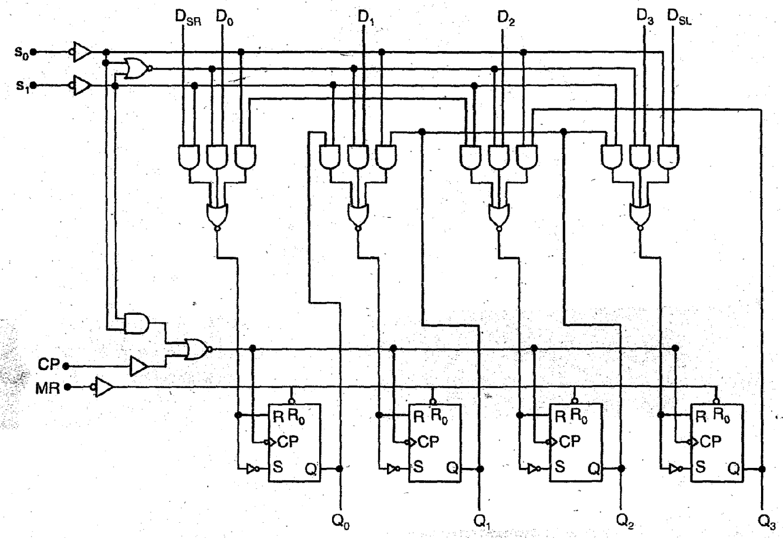

**Operating modes of IC-741 94**

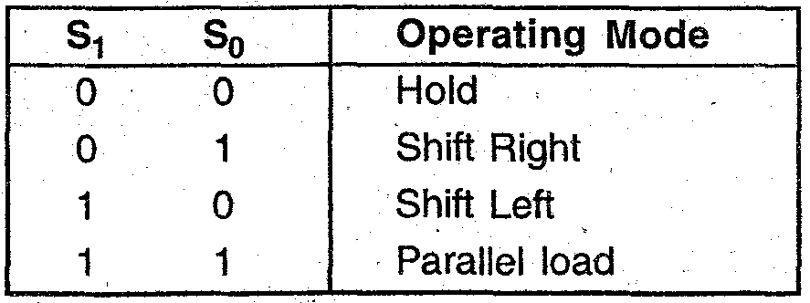

**ii). Write note on: 4 bit binary shift register.**

**Ans. 4 bit binary shift Register: This type of Shift Register allows shifting either to left or right side.**

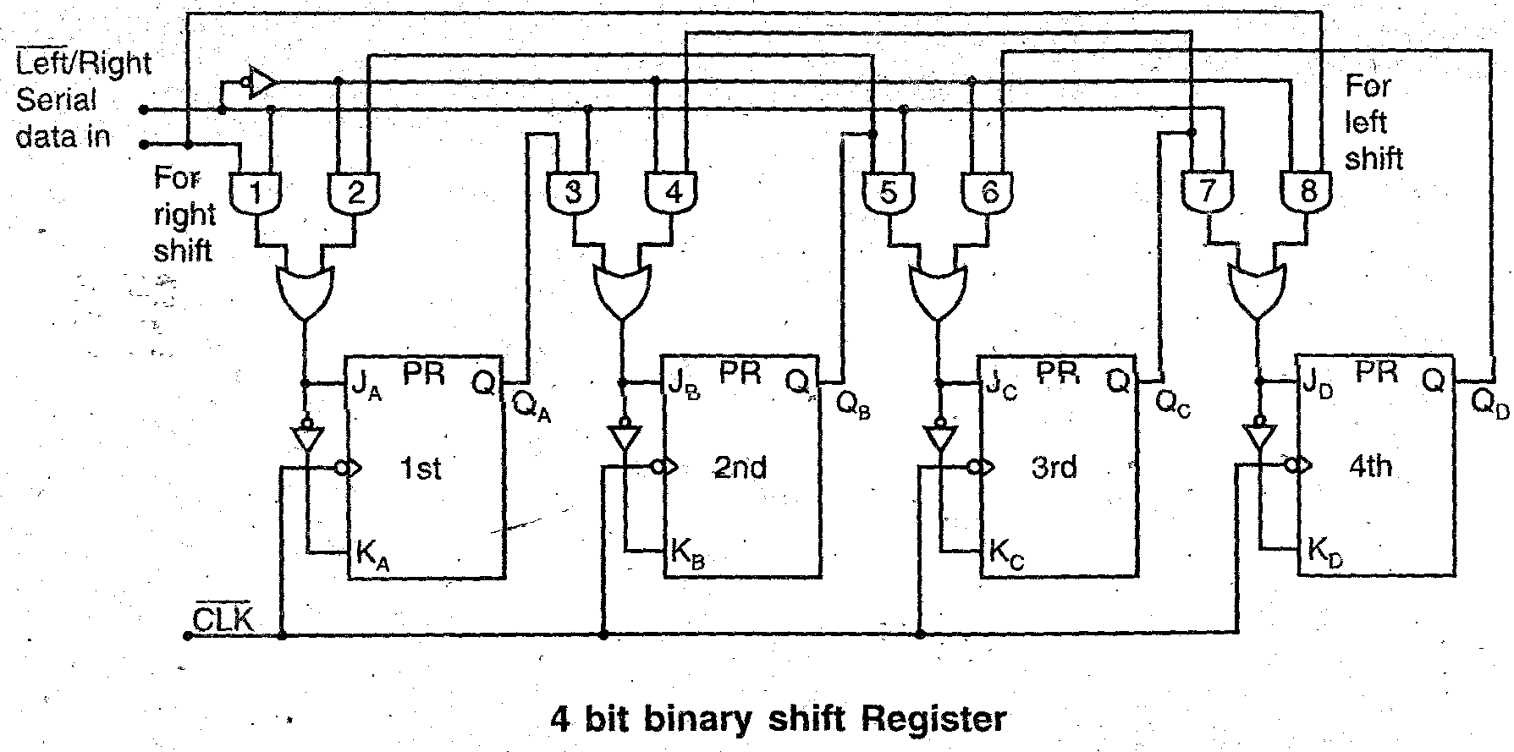

**Working Fig shows the bidirectional shift register When 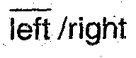signal IS High AND gates 1 3, 5, 7 are enabled and it enables the data shifting towards right Whereas when signal is Low AND gates 2, 4 6, 8 are enabled the data shifting is towards left Then the Q states of each flip-flop passes through the A and KA input of each proceeding flip flop When clock pulse arrives the data shift one place to right or left depending on .**

**5. Design a J-K counter that goes through states 2, 4, 5, 7, 2, 4…… is the counter-self starting.**

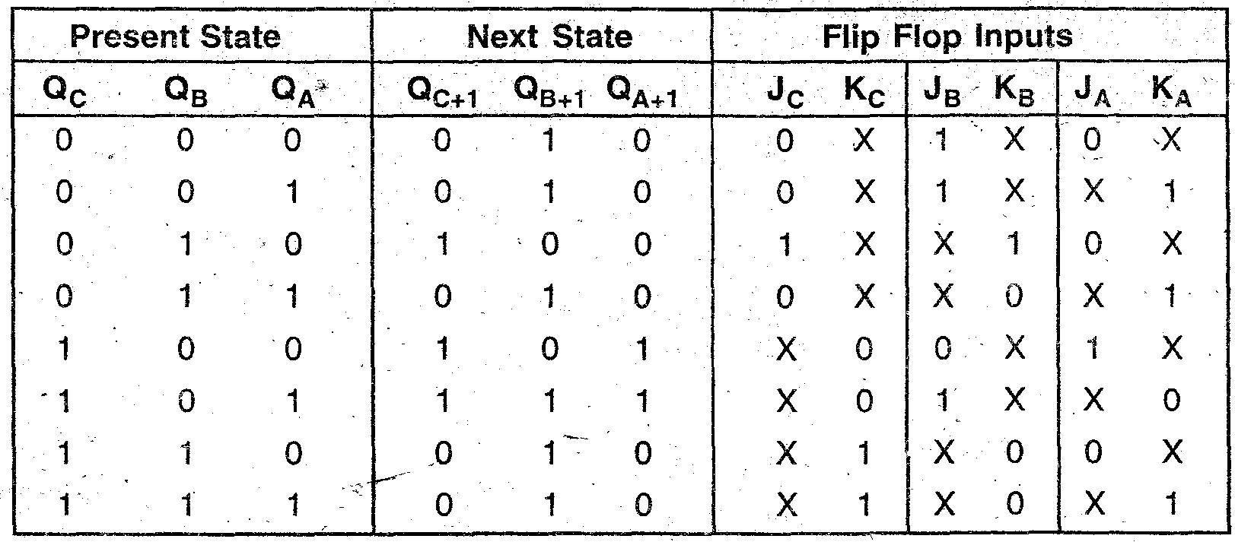

**K-maps**

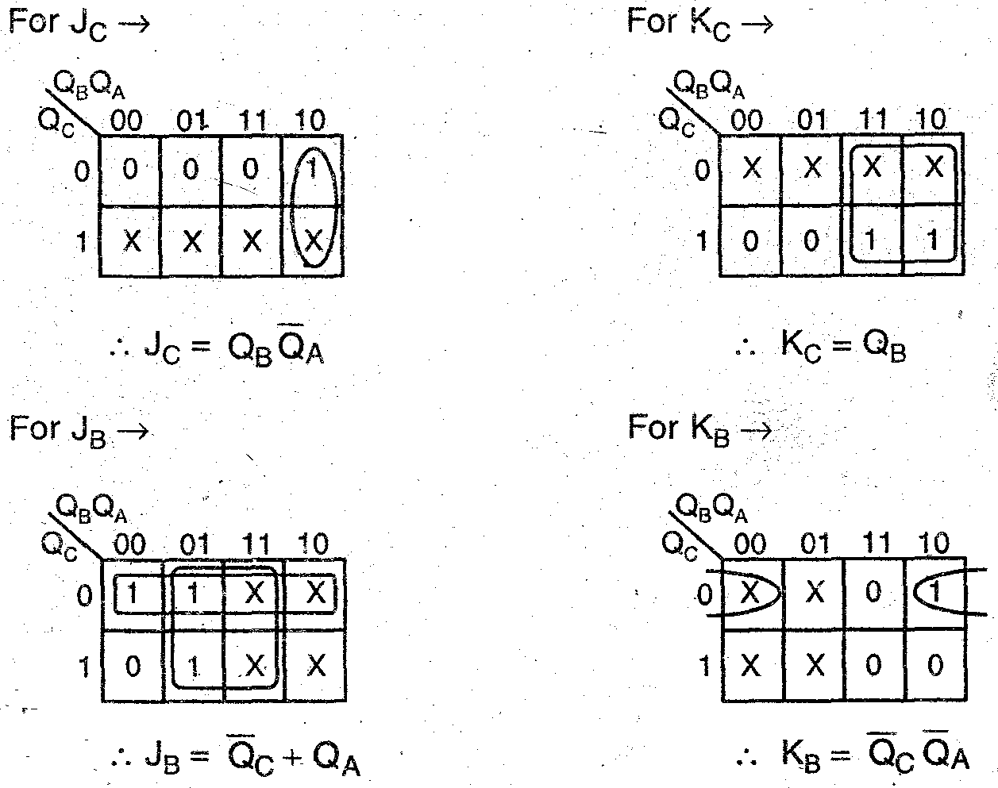

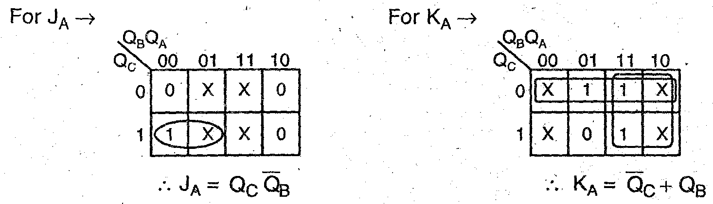

**Circuit**

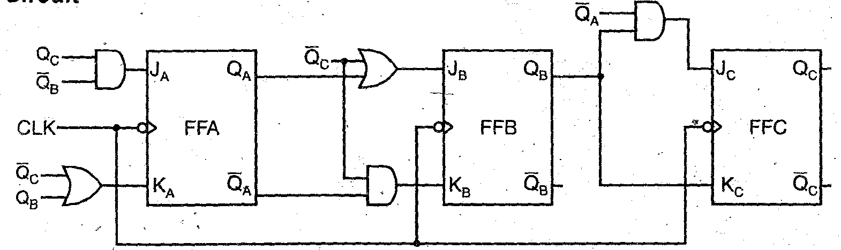

**6. Design a BCD counter using JK flip-flops.**

**Ans. The BCD decade counter counts from 0000 to 1001 as shown in diagram. The**

**invalid states 1010 to 1111 should given next states as 0000 which is done by reset logic connected to clear input of all the flip-flops.**

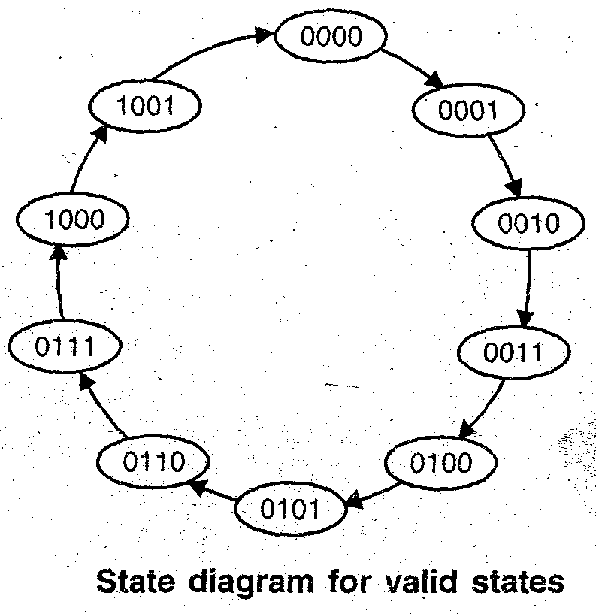

**Truth table of BCD counter: Reset logic output for clear.**

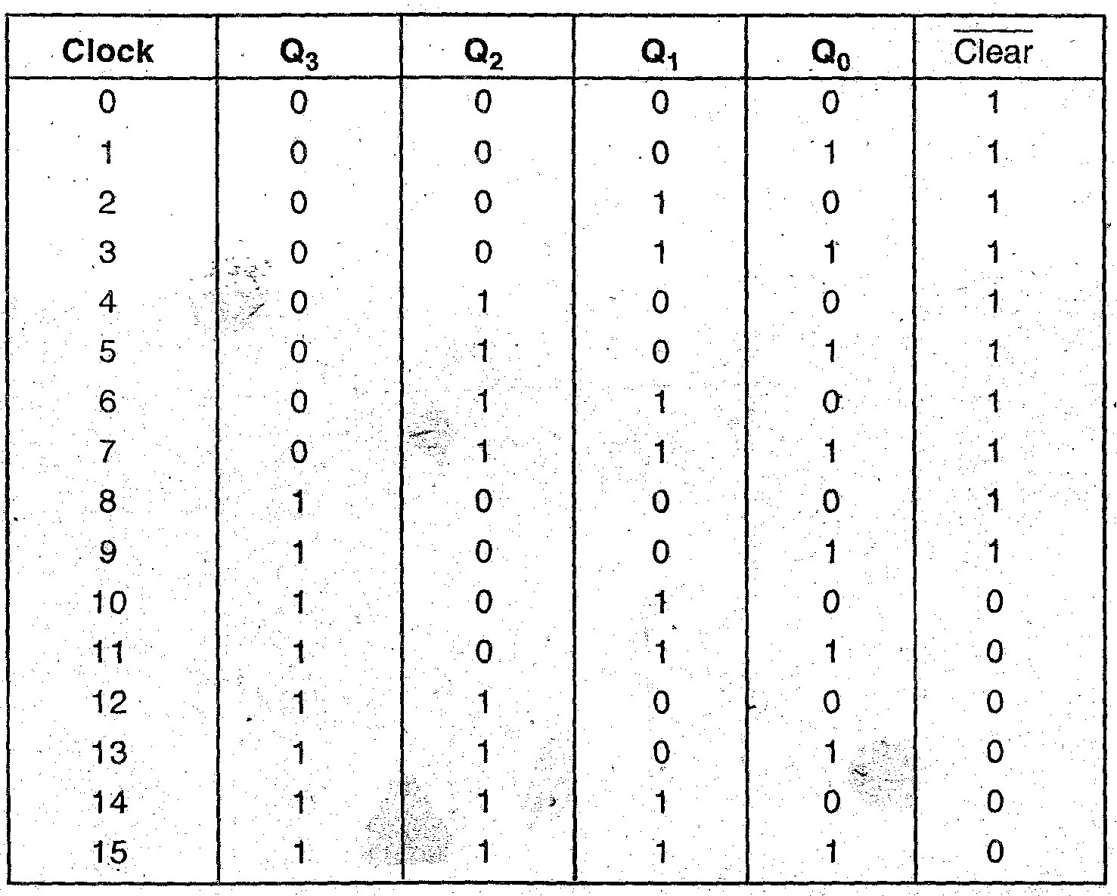

**K-map:**

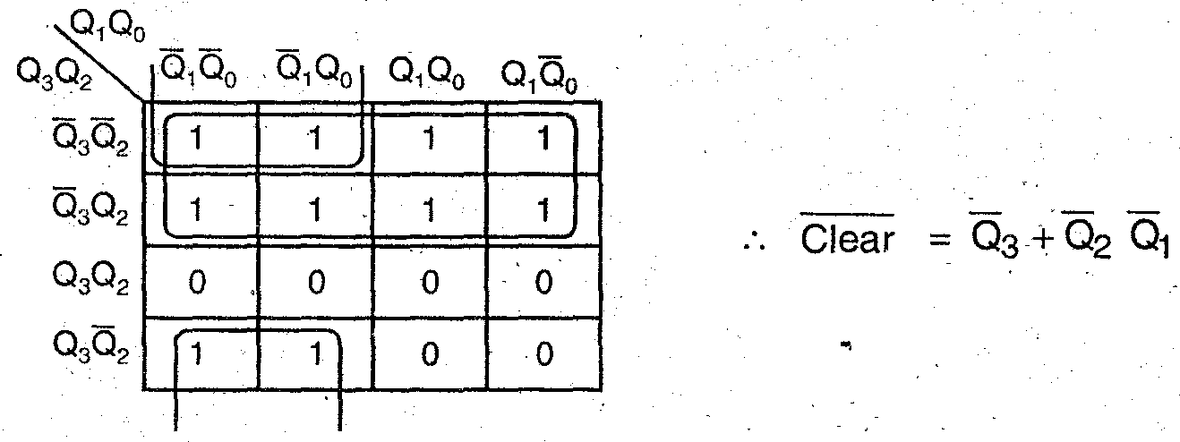

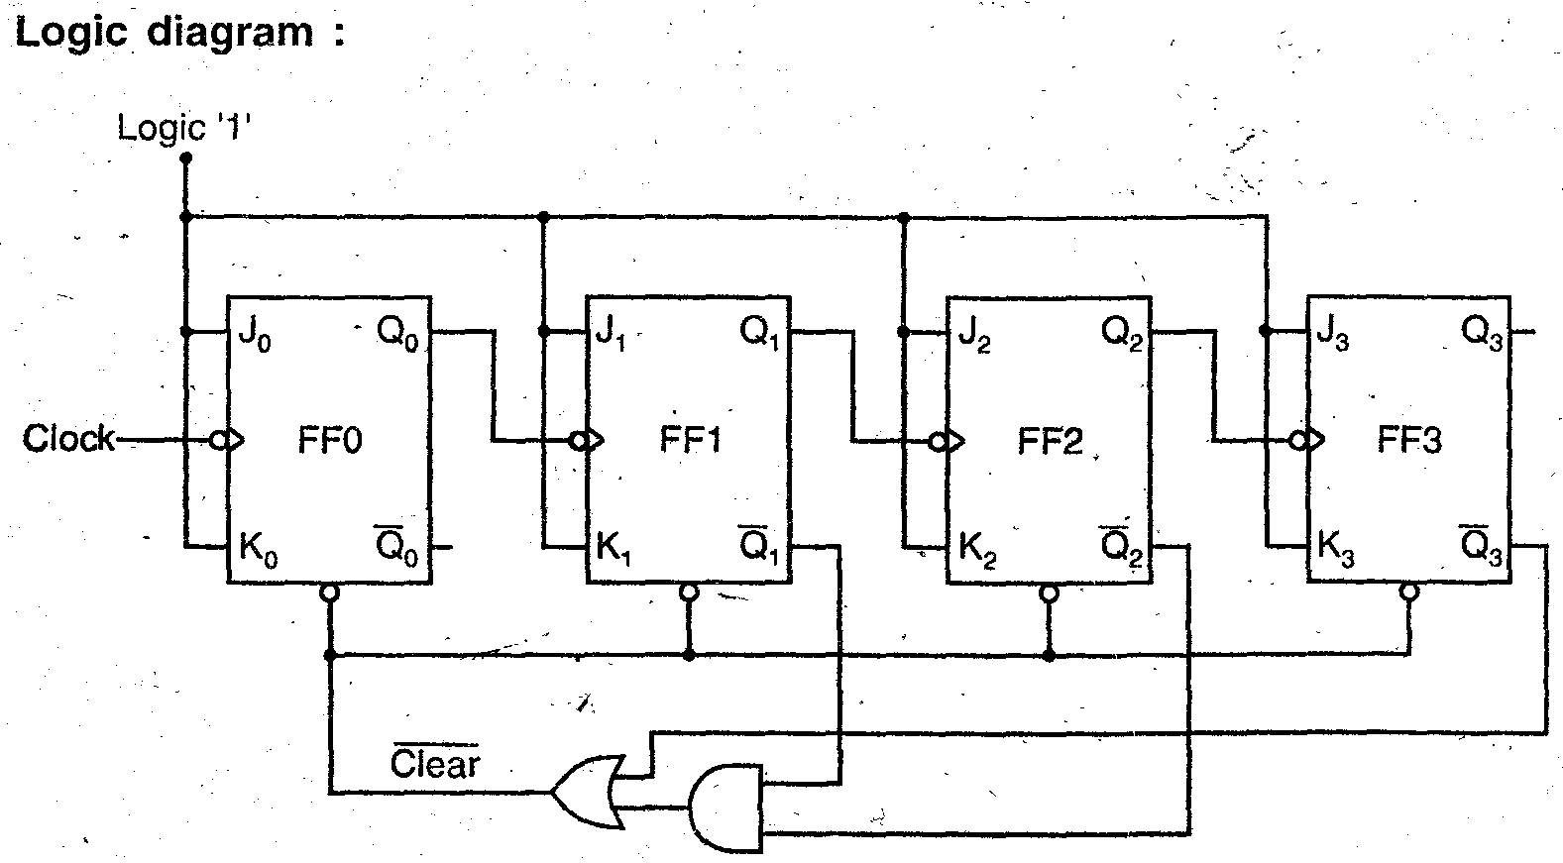

**7.i) Design an up-down counter using JK Flip-flop to count 0, 2, 3, 6, 4, 0….**

**Ans. Up-down counter counts (0, 2, 3, 6, 4, 0,......).**

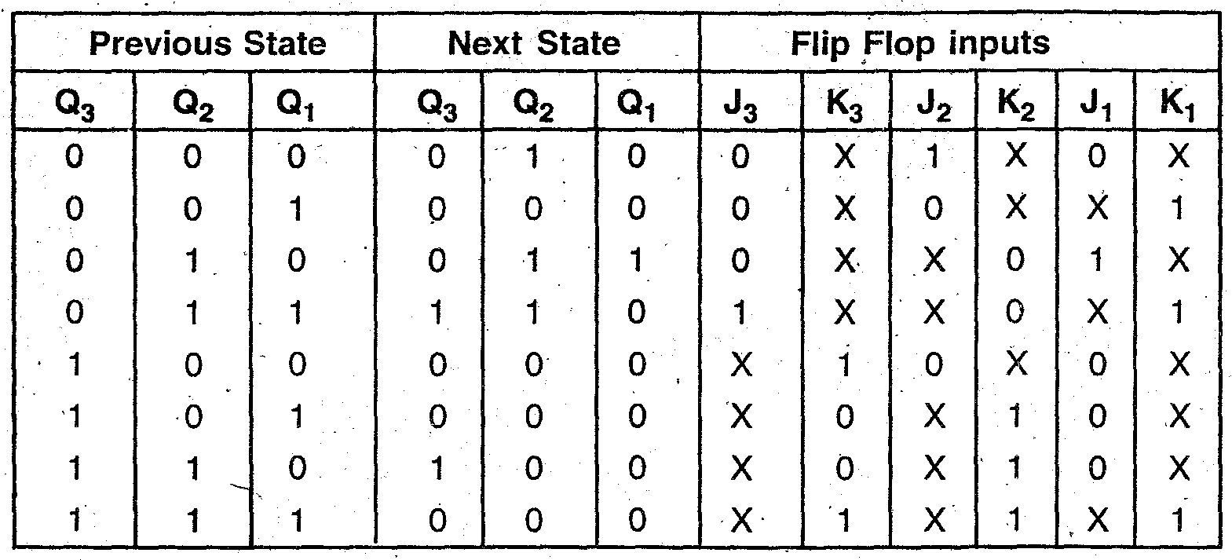

**K-maps**

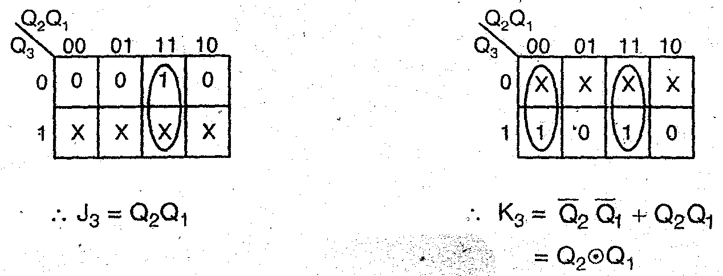

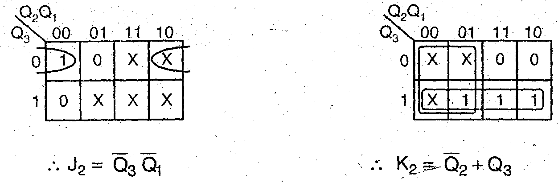

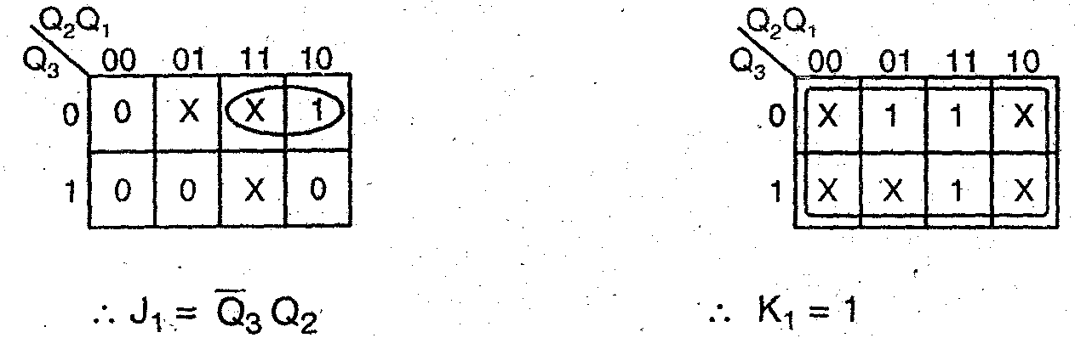

**Circuit diagram**

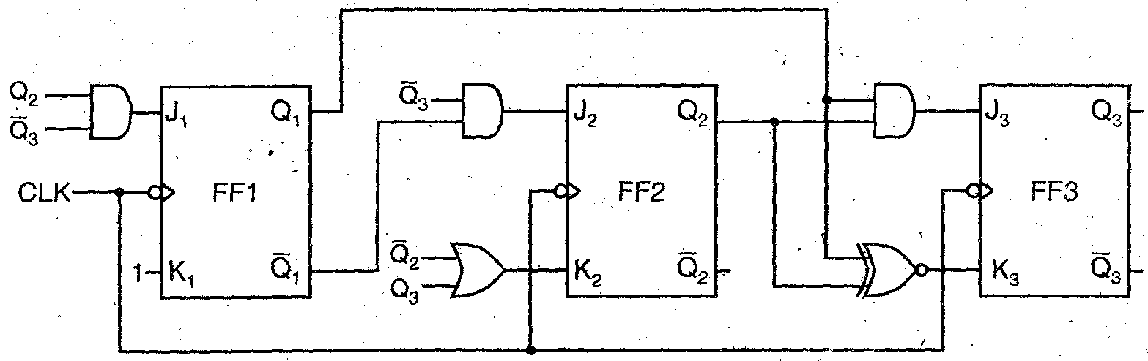

**ii). Design an up-down counter using D-flip-flops to count 0, 3, 2, 6, 4, 0,........**

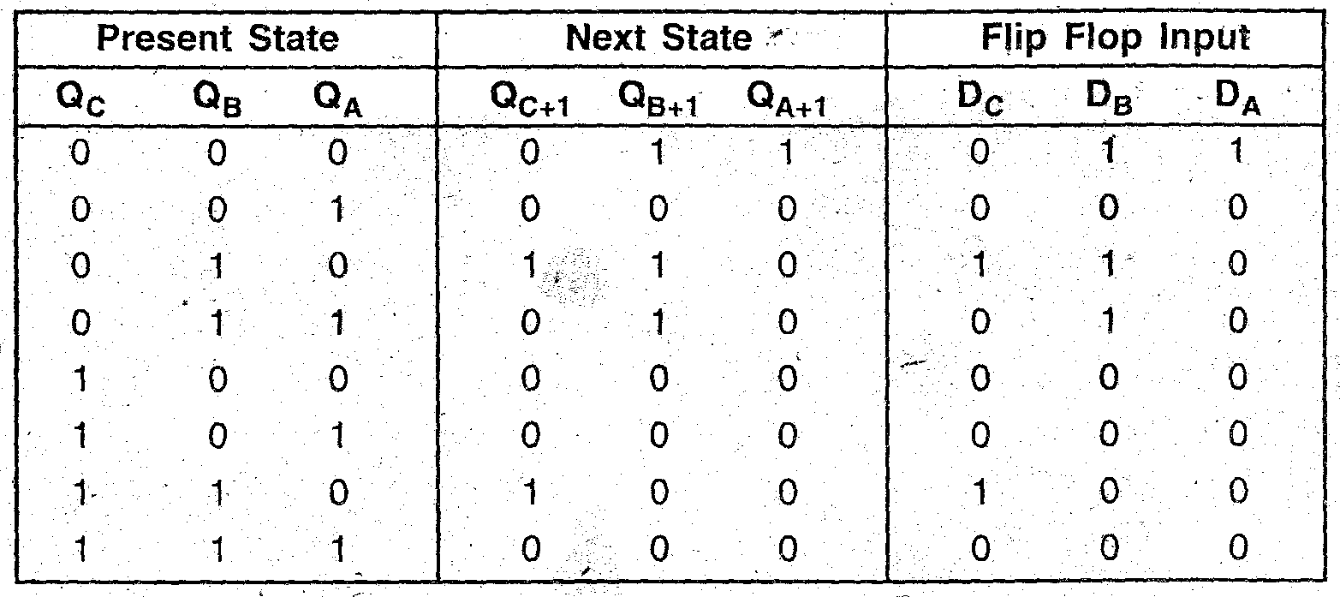

**K-maps**

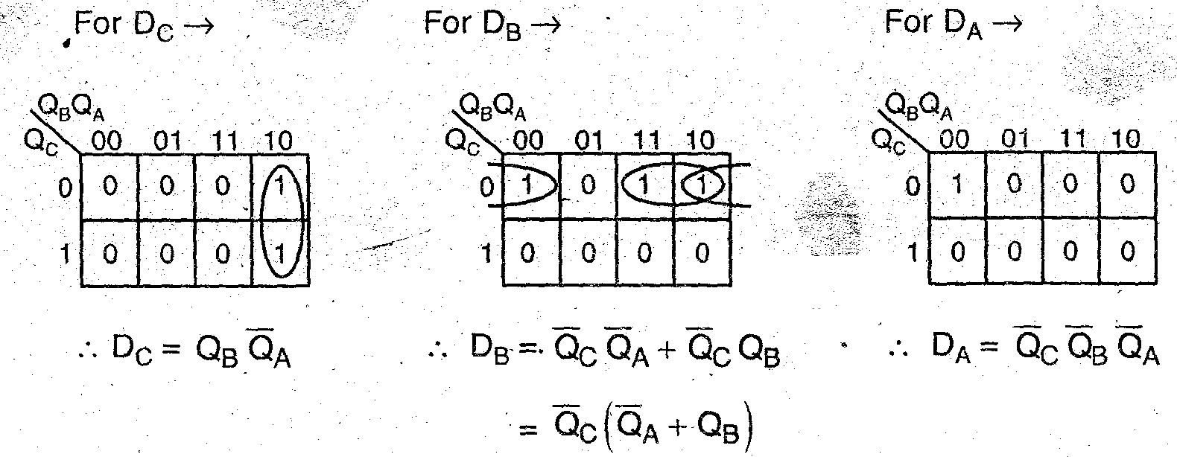

**Implementation of circuit:**

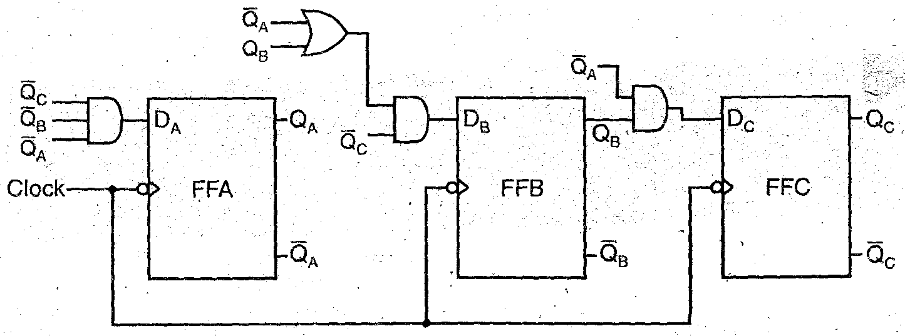

**UNIT- 4**

**ASYNCHRONOUS SEQUENTIAL LOGIC**

**PART - A**

1. **Define race condition in asynchronous sequential circuits.**
2. **Define hazard. What happens when hazard occurs in a logic circuit?**
3. **What is lock out condition?**
4. **What are the steps for designing a sequential circuit?**
5. **Define primitive flow table.**
6. **Distinguish fundamental mode circuit and pulse mode circuit.**
7. **Explain critical and non-critical race.**
8. **Define Essential Hazard.**
9. **What is ASM chart?**
10. **Explain the difference between the stable state and the unstable state.**

**PART-B**

**1.Design an asynchronous sequential circuit with two inputs x1 and x2 and one output Z. Initially both inputs are equal to zero. When x1 or x2 becomes ‘1’, the output Z becomes 1. When the second input also becomes ‘1’, the output changes to 0. The output stays at zero until the circuit goes back to the initial stage.** 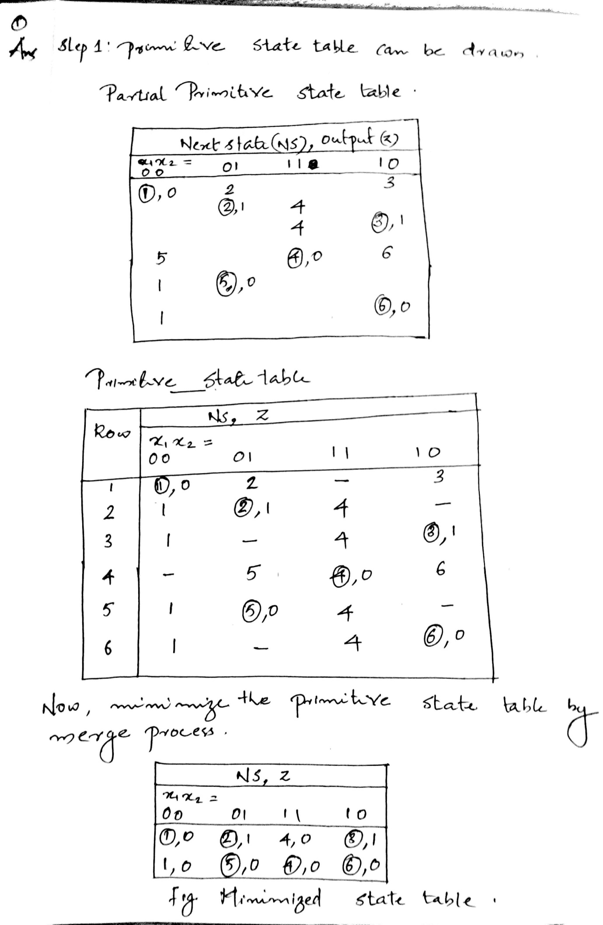

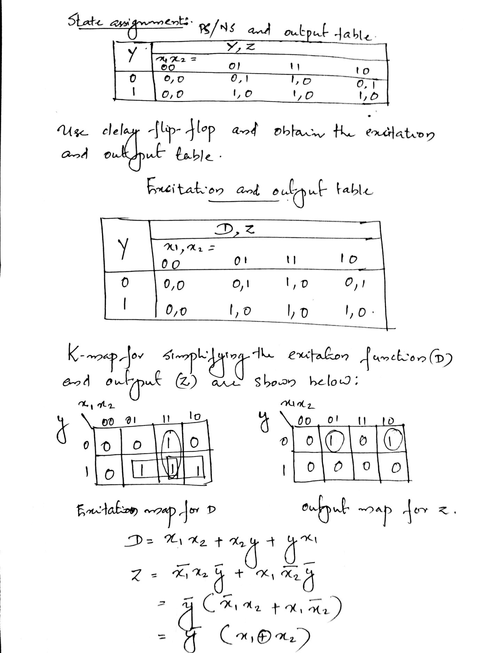

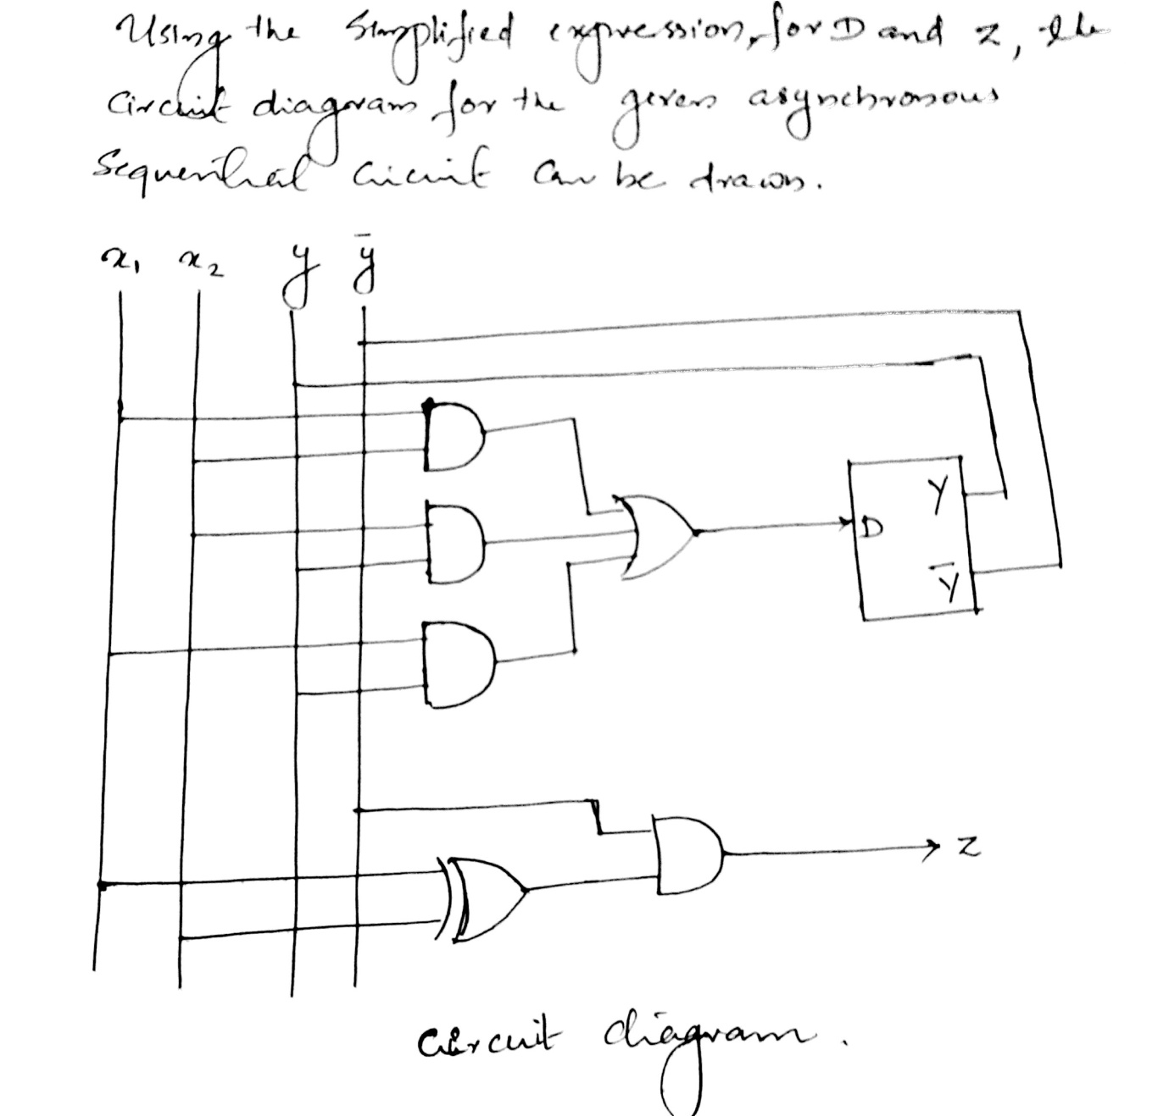**2. Explain about hazards in digital systems.**

In digital logic, a **hazard** in a system is an undesirable effect caused by either a deficiency in the system or external influences. Logic hazards are manifestations of a problem in which changes in the input variables do not change the output correctly due to some form of delay caused by logic elements (NOT, AND, OR gates, etc.) This results in the logic not performing its function properly. The three different most common kinds of hazards are usually referred to as **static**, **dynamic** and **function hazards**. Hazards are a temporary problem, as the logic circuit will eventually settle to the desired function. However, despite the logic arriving at the correct output, it is imperative that hazards be eliminated as they can have an effect on other connected systems.

A **static hazard** is the situation where, when one input variable changes, the output changes momentarily before stabilizing to the correct value. There are two types of static hazards:

Static-1 Hazard: the output is currently 1 and after the inputs change, the output momentarily changes to 0 before settling on 1.



Static-0 Hazard: the output is currently 0 and after the inputs change, the output momentarily changes to 1 before settling on 0.



A **dynamic hazard** is the possibility of an output changing more than once as a result of a single input change. Dynamic hazards often occur in larger logic circuits where there are different routes to the output (from the input). If each route has a different delay, then it quickly becomes clear that there is the potential for changing output values that differ from the required / expected output. e.g. A logic circuit is meant to change output state from **1** to **0**, but instead changes from **1** to **0** then **1** and finally rests at the correct value **0**. This is a dynamic hazard.



**3. Give the design Procedure for asynchronous sequential circuit.**

Asynchronous sequential logic expresses memorizing effect by fixing moments of time, when digital device changes its state. These moments are represented not in explicit form, but taking into account principle “before/after” in temporal relations of logical values. For asynchronous logic it is sufficient to determine a sequence of switchings irrespective of any connections of the corresponding moments with real or virtual time. Theoretical apparatus of sequential logic consists of mathematical instruments of sequention and venjunction as well as of logic-algebraic equations on their basis. An asynchronous sequential circuit is a sequential circuit whose behavior depends only on the order in which its input signals change and can be affected at any instant of time.

Memory (delay) elements are either latches (unclocked) or time-delay elements (instead of clocked FFs as in a synchronous sequential circuit). + An asynchronous sequential circuit quite often resembles a combinational circuit with feedback. + Faster and often cheaper than synchronous ones, but more difficult to design, verify, or test (due to possible timing problems involved in the feedback path).

**Analysis Procedure**

The analysis consists of obtaining a table or a diagram that describes the sequence of internal states and outputs as a function of changes in the input variables. 1. Determine all feedback loops. 2. Designate each feedback-loop output with Yi and its corresponding input with yi for i = 1; : : : ; k, where k is the number of feedback loops. 3. Derive the boolean functions for all Y ‟s. 4. Plot the transition table from the equations.

**Design Procedure**

1. Obtain a primitive flow table. 2. Reduce the flow table. 3. Assign binary state variables to obtain the transition table. 4. Assign output values to the dashes to obtain the output maps. 5. Simplify the excitation and output functions. 6. Draw the logic diagram.

**4. Design a gated latch circuit with two inputs, *G* (gate) and *D* (data), and one output *Q*. The gated latch is a memory element that accepts the value of *D* when *G* = 1 and retains this value after *G* goes to 0. Once *G* = 0, a change in *D* does not change the value of the output *Q*.**

**State table**



**Primitive Flow table**



**Informal Merging**



**Formal Merging Compatible Pairs**



**Maximal Compatibles Reduced Table**

 

**Logic Diagram**



**5. i) Write HDL programme for the given circuit.**



**module smpl_circuit(A,B,C,x,y);**

**input A,B,C;**

**output x,y;**

**wire e;**

**and g1(e,A,B);**

**not g2(y, C);**

**or g3(x,e,y);**

**endmodule**

**ii) Write HDL for the expression.** x = A.B + C1 y = C1

module circuit_bln (x,y,A,B,C);

input A,B,C;

output x,y;

assign x = A | (B & ~C);

assign y = ~C ;

endmodule

**iii) Write HDL for MUX in behaviour mode.**

module mux2x1_bh(A,B,select,OUT);

input A,B,select;

output OUT;

reg OUT;

always @ (select or A or B)

if (select == 1)

OUT = A;

else

OUT = B;

Endmodule

**6) Design an asynchronous circuit that has two inputs x1 and x2 and one output Z. The circuit is required to give an output whenever the input sequence (0,0), (0,1) and (1,1) received but only in that order.**

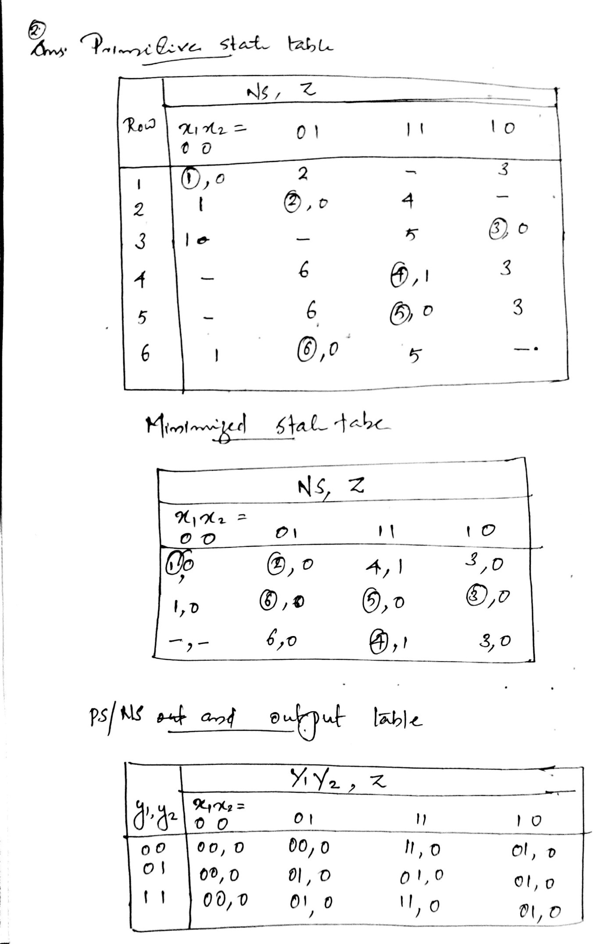

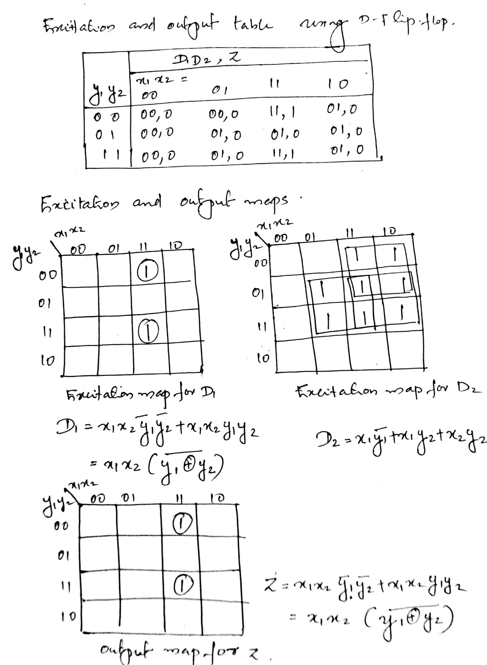

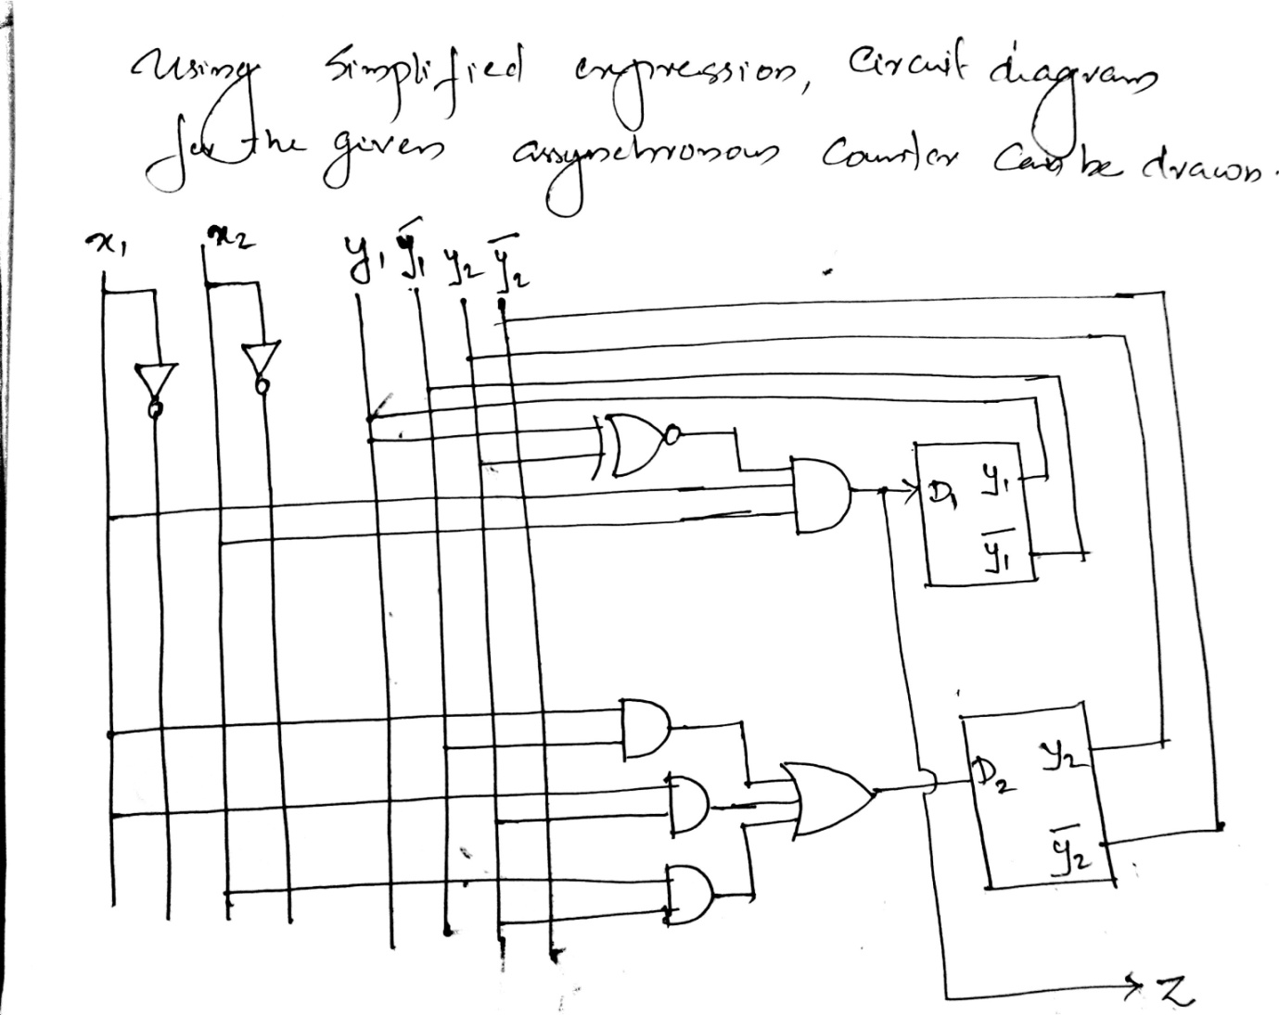

**7) Design an asynchronous circuit that will output only the first pulse received whenever a control input is asserted from LOW to HIGH state. Any further pulses will be ignored.**

**Ans: Block diagram and timing diagram**

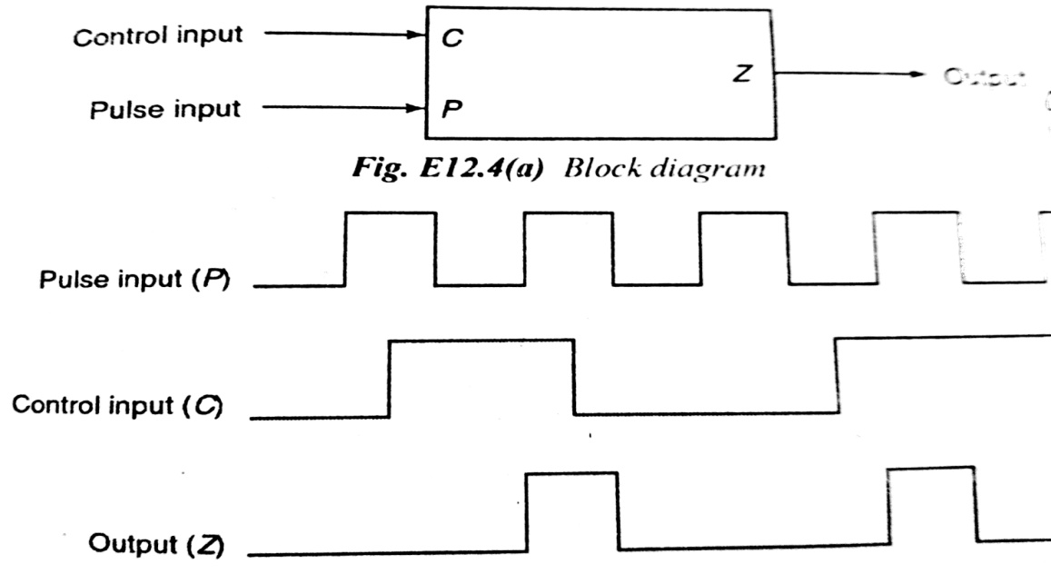

**Primitive state table:**

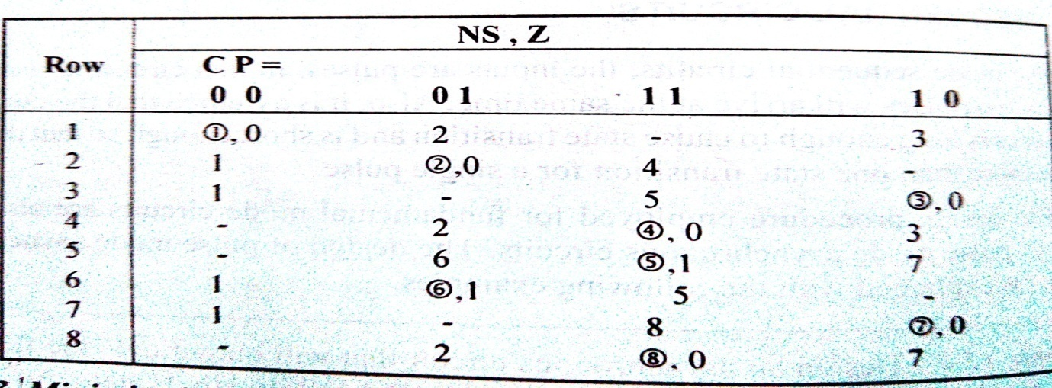

**Minimized primitive state table:**

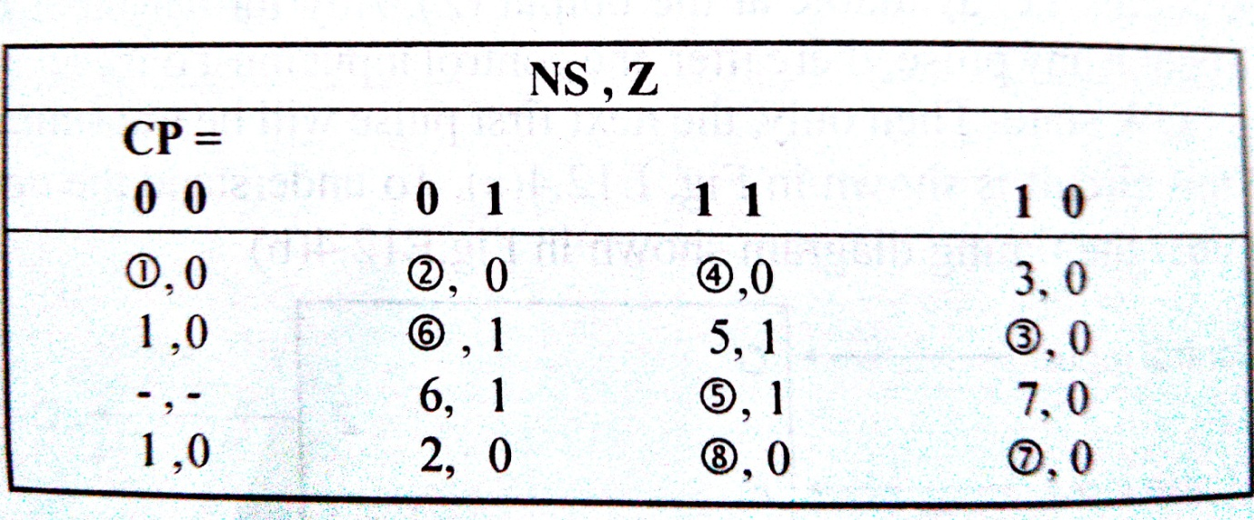

**PS/NS and output table:**

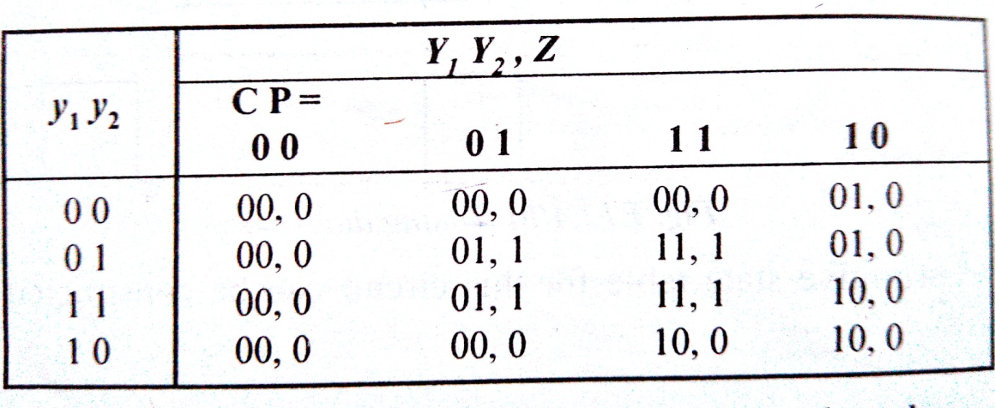

**Excitation and output table:**

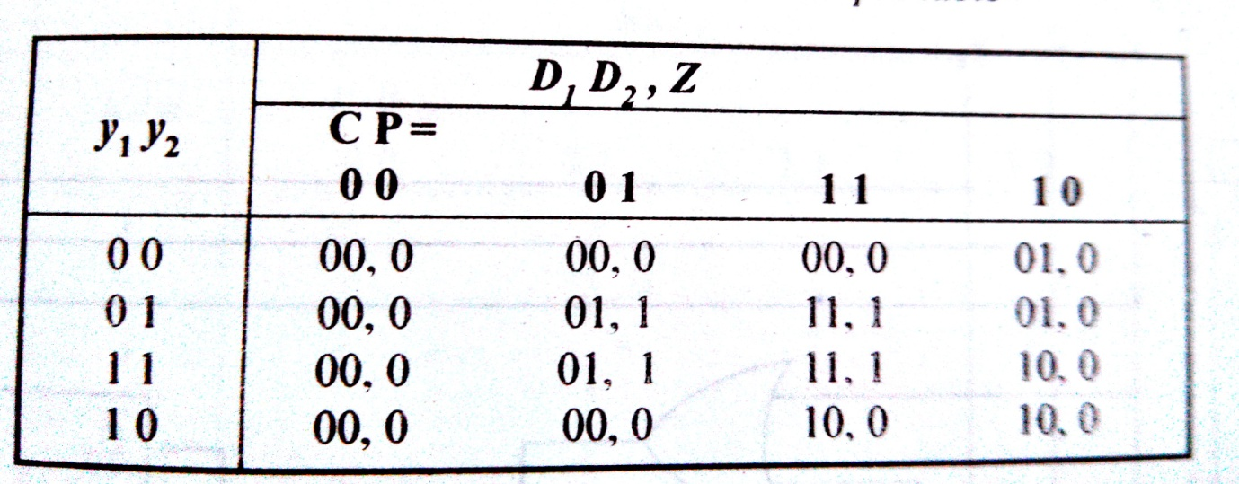

**K-maps for simplifying excitation and output functions:**

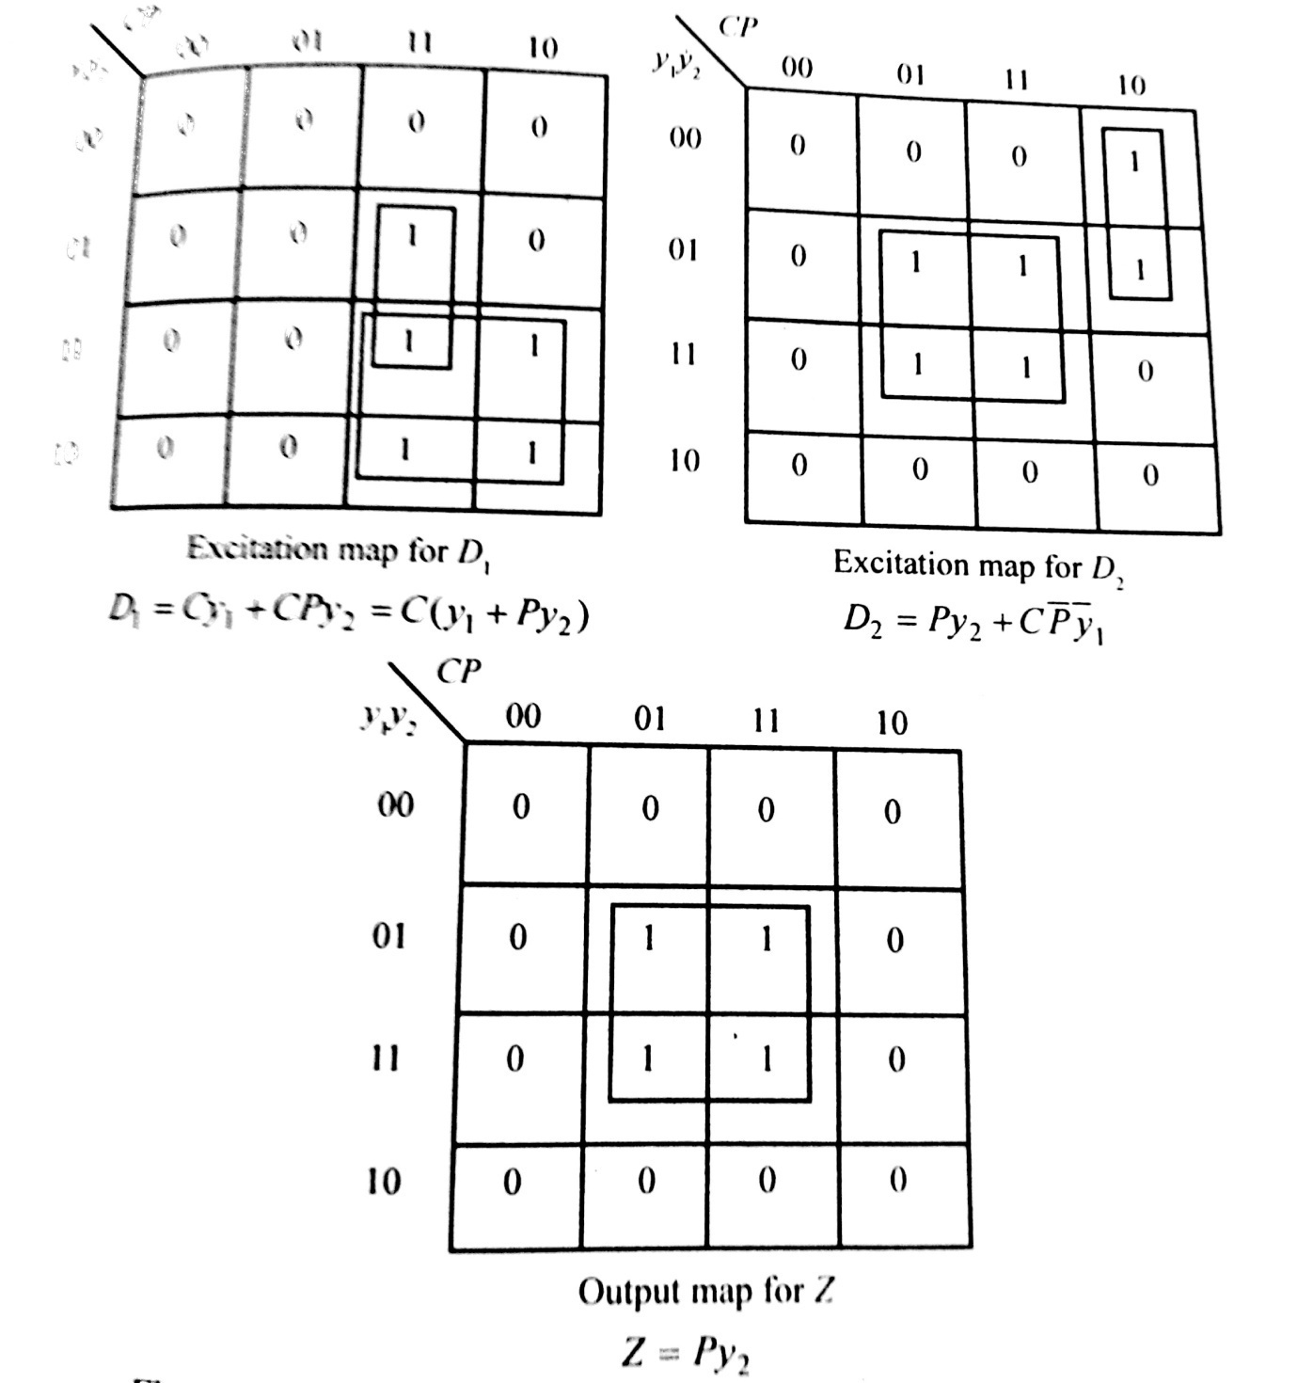

**Circuit diagram:**

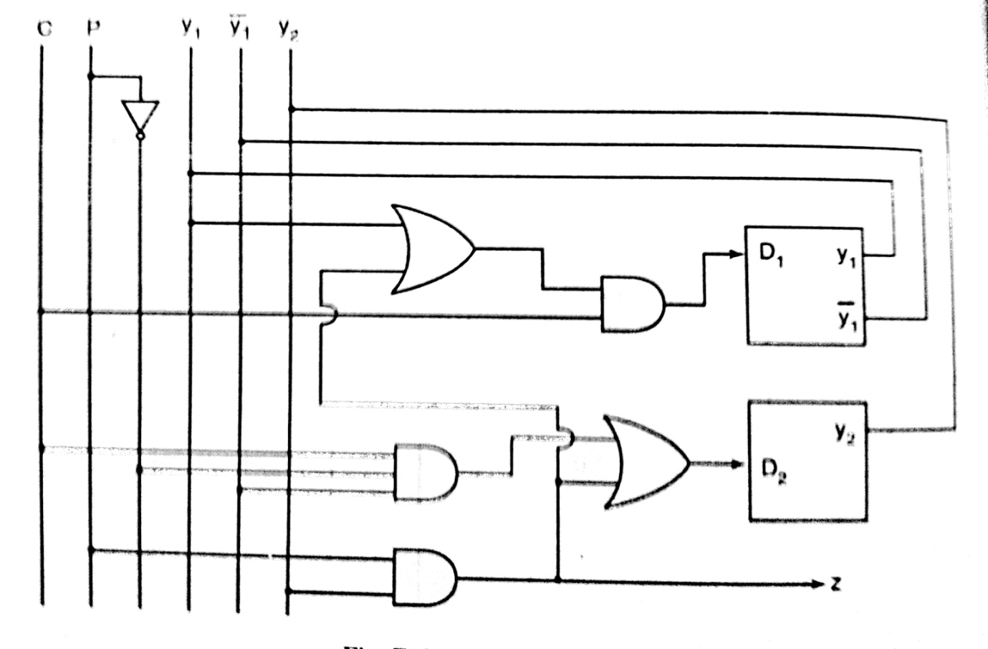

**UNIT 5**

**MEMORY AND PROGRAMMABLE LOGIC**

**PART A**

1. **How does the architecture of a PAL differ from a PROM?**
2. **Distinguish between EPROM and EEPROM**
3. **What is a PLA? Describe its uses.**
4. **Distinguish between PAL and PLA.**
5. **Explain error detection and correction.**
6. **What do you mean by PLD’s?**
7. **What is Configurable Logic Block?**
8. **What are the major drawbacks of the EEPROM**
9. **What is volatile and non- volatile memory?**
10. **How many data inputs, data outputs and address inputs are needed for a 1024 ×4 ROM?**

**PART B**

**1. i)** **What is PAL?**

**Ans. PAL:** PAL is known as programmable array logic. It is a programmed logic device with OR arrays fixed and AND arrays programmable. Because only AND gates are programmable, the PAL is easier to program, but it is not as flexible as the PLA (programmable logic array). For example : We have a boolean function given by

Y (A, B, C,) = 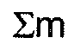 (1, 3, 4, 6) and we have to implement it by using PAL. It is as shown:

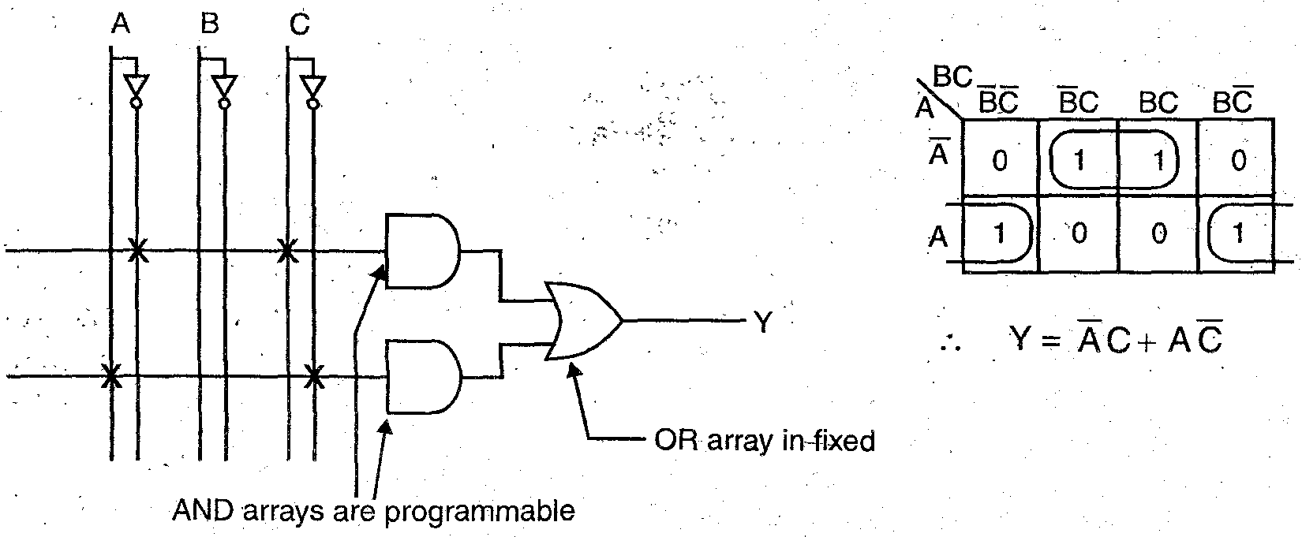

**ii) Implement the boolean function using PAL.**

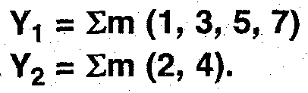

**Ans.**Let the input variables are A, B and C. The K-map minimization is as shown:

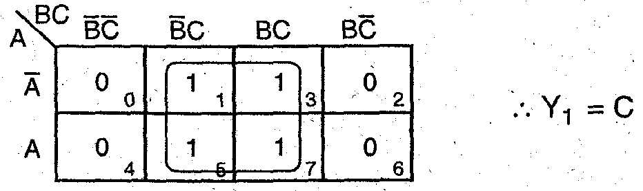

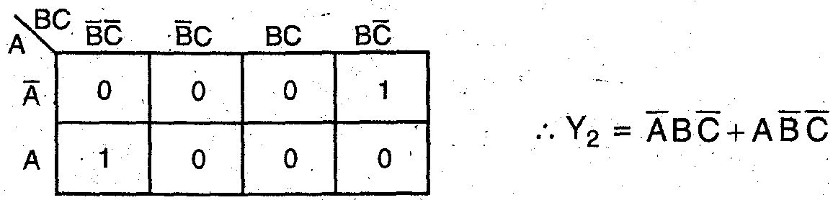

 Implementation using PAL:

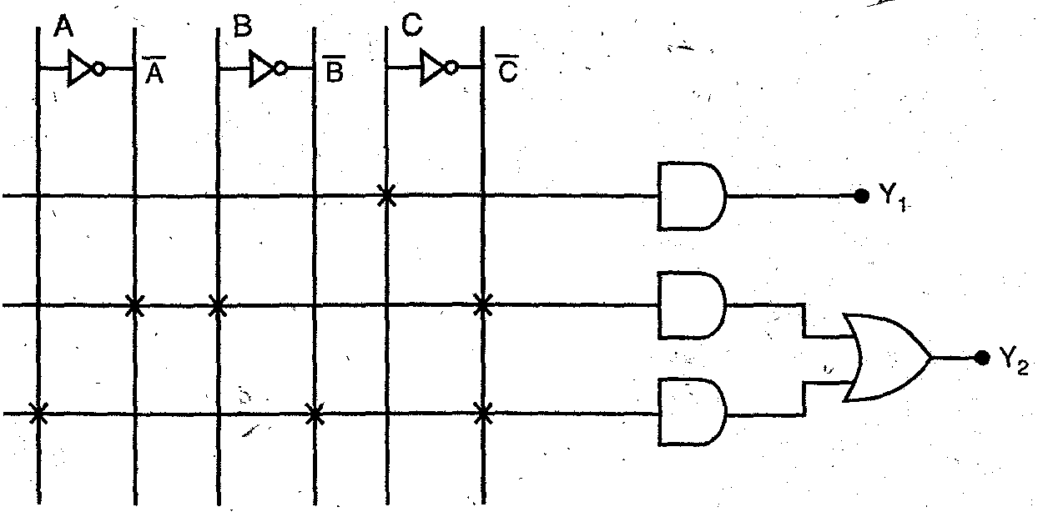

**2.Describe with diagram internal architecture of PLA. Design half adder circuit using PLA**

**Ans** PLA is Programmable Logic Array It is used where the number of don’t care conditions are excessive In PLA’s both AND and OR arrays are programmable The ANI and OR gates are fixed for any PLA chip It depends on the number of inputs and outputs of PLA.

Let us take an example of Half Adder to illustrate the diagram internal architecture of PLA:

Truth Table of Half Adder:

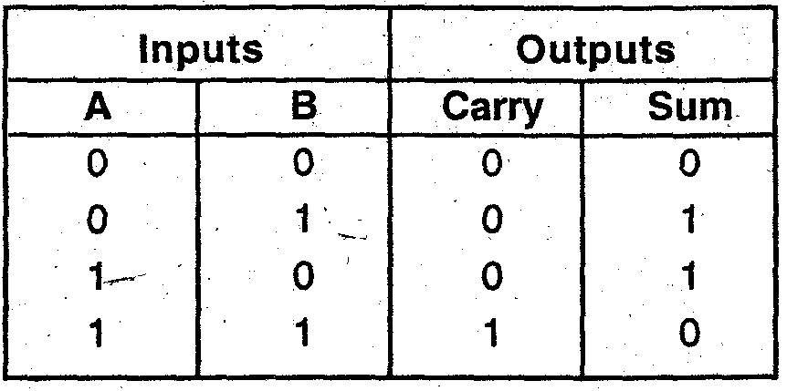

Thus, carry = A B and sum = 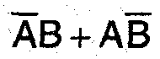

Implementation of Half Adder using PLA is as shown:

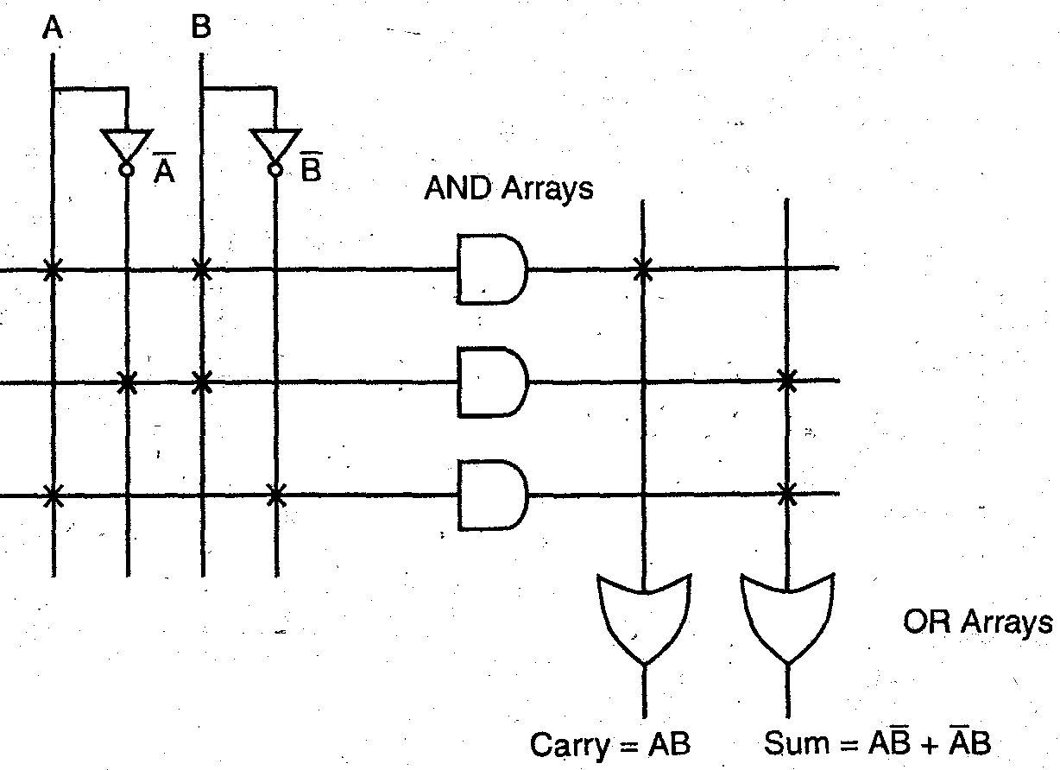

**3. i) Give the classification of memories. The difference between static and dynamic memories.**

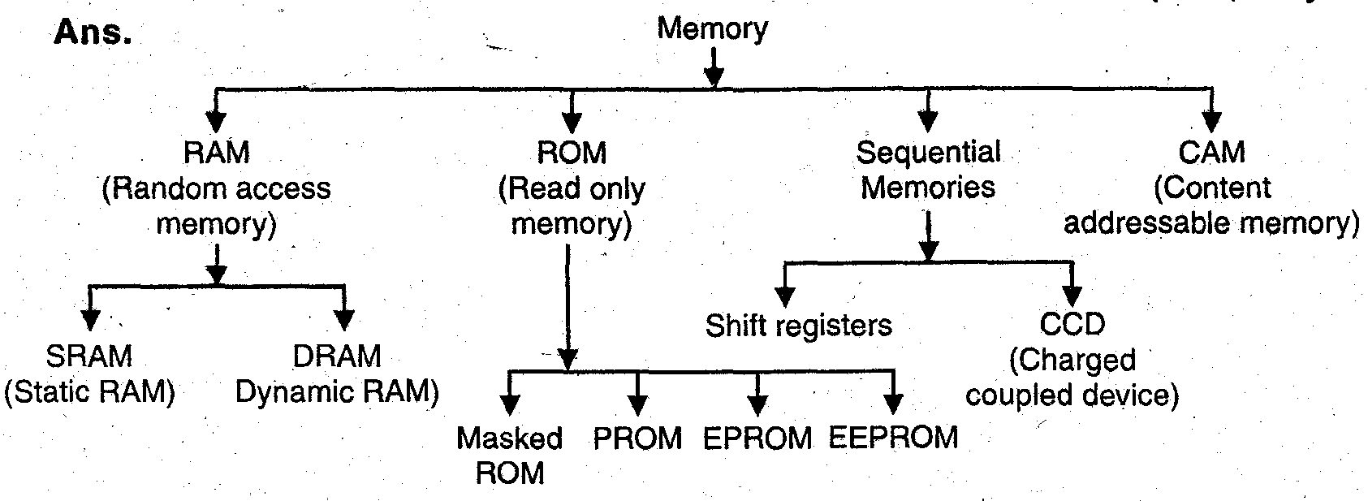

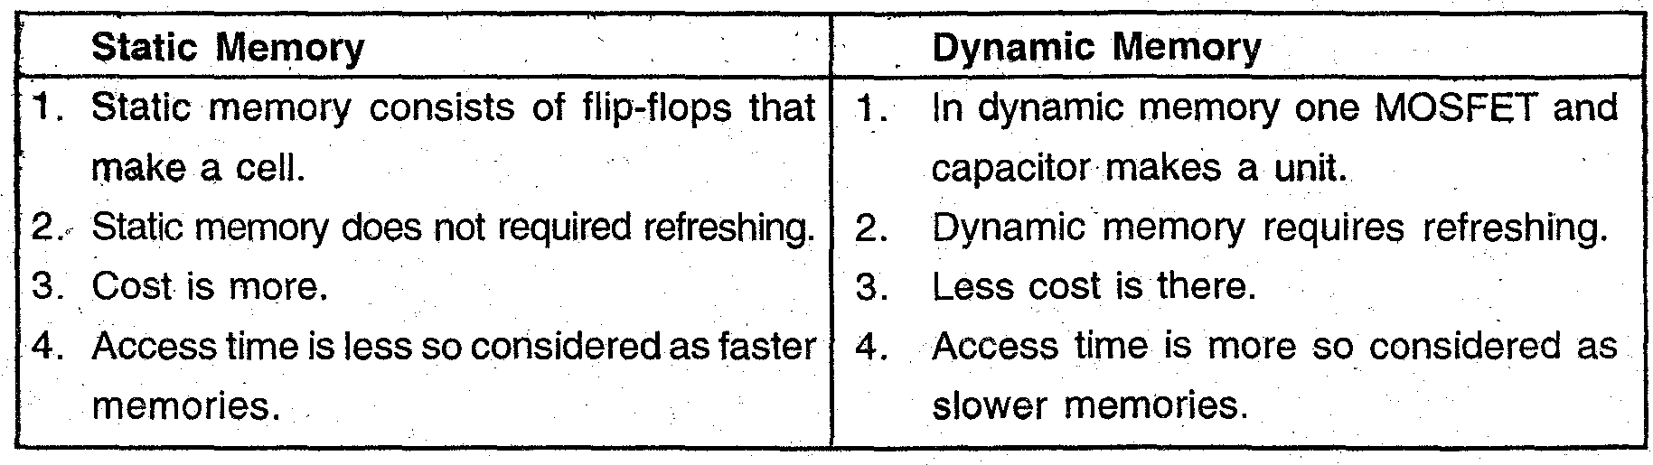

**ii) What are the various types of ROMs? Discuss their relative advantages and disadvantages.**

**Ans. ROM** : In ROM, read and write operation cannot be periormed with equal ease always read operation is easier than write operation. It is used to store information which is (I) Permanent group includes ; masked ROM and PROM (ii) Semi permanent group include; EPROM and EE-PROM. Five types of ROM-masked ROM, PROM, EPROM, EE-PROM and flash memory are described in the following paragraphs.

**Masked ROM** : Programming is done through masking and metallization. process. Manufactures provides programmed ROM, user cannot write into this memory.

**PROM** : Programmable Read Only Memory user can program (write) the PROM through special PROM programmer. It can be written (programmed) once only, user cannot rewrite this memory.

**EPROM** : Erasable Programmable ROM. This memory stores a bit by charging the floating gate of an FET. The chip can be reused may times i.e., user can write this memory many time. Erasing is done using UV light through a window over the memory chip called quartz window. Erasing process cannot be done byte by byte or block by block, entire information will be erased at once,- after exposing the ROM in U.V. light. Therefore, erasing process is slower and time consuming it takes 15 to 20 minutes.

**EEPROM :** Electrically Erasable PROM. This memory is functionally similar to EPROM, except that information can be altered by using electrical signals at the register level rather than erasing the information i.e., it can be erased information byte to byte.

**Advantages and Disadvantages:**

**Advantages:**

1. Low cost 2. High speed 3. Flexibility in system design 4. ROM is non-volatile memory

**Disadvantages:**

1. In EPROM selective erasing is not possible. One time all the locations are erased.

2. IROM has to be removed from socket and put in eraser for erasing.

**iii) A certain memory stores 8 k x 16 bit words. How many data input lines, data output lines and address lines does it have ? What is its capacity in bytes?**

**Ans.**Memory is M x N form where M are memory locations and N are data input lines.

Here                          M = 8K

                                  N = 16

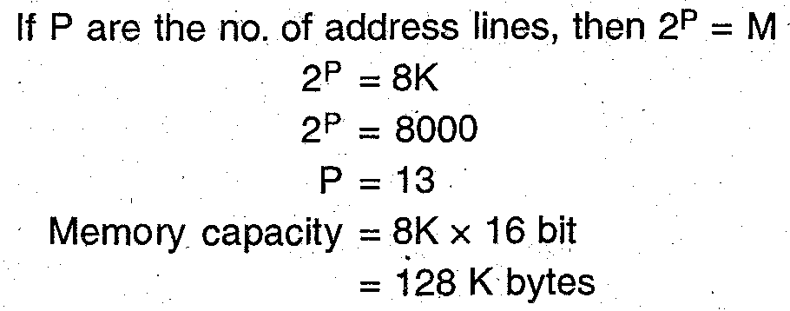

**4. Write short note on Classification and characteristics of memories.**

**Ans**. Classification and characteristics of memories Various memory devices can

be classified on the basis of:

1. Principle of operation

2. Physical characteristics

**1. Principle of operation :** The most commonly used memories are

(a) Sequentially accessed memory.

(b) Random access memory (RAM)

(c) Read only memory (ROM)

(d) Content addressable memory (CAM)

**(a) Sequentially accessed memories**: In these type of memories the time required to access memory location is different for different locations. These are of basic two types:

(i) Shift registers

(ii) Charge coupled devices (CCDs).

**(b) RAM :** Random access memory is the memory which is used for both read and write operation i.e. data can be read or placed into. Here access time is same for each location. It is of two types:

(i) SRAM i.e. Static RAM

(ii) DRAM i.e. Dynamic RAM

**(c) ROM :** Read only memory is the type from which data can be repeatedly read out but cannot be written into it. It is of two types

(i) Mask programmable ROM

(ii) Programmable ROM.

In case of Mark Programmable ROM it is programmable at the time of manufacturing according to the information specified by the customer, and cannot be changed after packing.

In case of programmable ROM, data is permanently stored but can be erased either by

ultraviolet light or electrically using electric voltage.

**(d) CAM :** Content address memory is a special purpose RAM which performs association operation in addition Read/Write operation.

**2. Physical Characteristics :** These are of two types :,

(a) Erasable or non-erasable (b) Volatile or non-volatile

**(a) Erasable or non-erasable** is a memory in. which the data stored can be erased or non-erased. For example : ROM is a non-erasable memory

RAM is erasable memory.

**(b) Volatile or non-volatile**: If the data stored in memory is lost where power is switched off then it is volatile memory. For example : RAM.

But if the data stored is not lost when power is switched off when it is called non-volatile.

For example : ROM.

**5. Explain the architecture and function of programmable logic arrays**

**Ans.** Programmable logic devices (PLD) are special type of ICs which can be programmed by the user and hence a combinational or sequential circuit can be implemented with these PLO s are of various types as programmable array logic (PAL) and programmable logic array (PLA) etc The block diagram of PLA device is as shown:

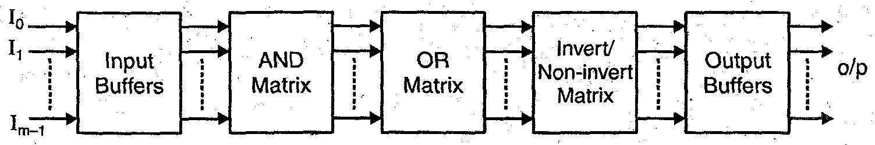

**Input Buffers** : These buffers amplify the input signal. These are also used to avoid the loading of sources connected at the input

**AND Matrix:** It can be used to implement the product terms in the SOP form Each AND has two matrix has connections are shown by (X) mark on the line.

**OR Matrix:** The OR matrix has ‘OR’ gates of two inputs The connections are shown by cross (X) mark, on the line.

**lnvert/Non-lnvert:** Matrix If the output in active low mode is required then it can be separated with this matrix otherwise it remain active high with non-invert matrix

**Output Buffers:**To amplify the output signal and to increase current source capability these buffers are used.

**6. i) Draw the block diagram of a typical CPLD and explain.**

PLAs, PALs, and equivalent reprogrammable devices such as GALs and EPLDs are often collectively referred to as simple programmable logic devices (SPLDs). Complex PLDs can be thought of as an arrangement of several SPLDs with in a single chip. In addition to providing a large number of array elements, they also provede a powerful method of *interconnecting* inputs and outputs to allow fairly complex circuits to be implemented within a single package. The block diagram of a typical CPLD is given below:

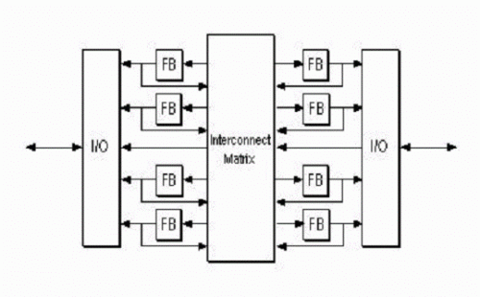

CPLDs are normally implemented using EPROM or EEPROM techniques rather than fuses, and are thus reprogrammable. EEPROM parts have the advantage of *in-circuit reprogrammability*, allowing their functionality to be changed with out the devices being removed from the board. This is particularly useful when performing *system upgrades*.

At present, devices with several thousands of gates are available, with delay times of only a few seconds. The propagation delay time can be predicted while implementing the design. A single CPLD might typically be used to implement a mixture of registers, decoders, multiplexers and counters. For eg., a 32-bit counter can be implemented using a single device.

**ii) Illustrate and discuss the architecture of FPGAs.**

FPGAs take the form of two-dimensional array of logic cell. These may be arranged in rows or more commonly in rectangular grid as shown in figure below:

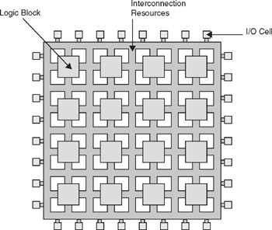

The size of the array varies considerably with small devices having about 64 cells, while larger devices may have more than 1000 cells. Between the cells of the array run groups of vertical and horizontal channels that can be used to route signals through the circuit. Programmable switches are used to interconnect these conductors and so provide point-to-point connections.

The programmable switches within FPGAs may be either one time programmable (OTP) or reprogrammable. OTP parts are based on the use of antifuse rather than the conventional fuses used in PALs.

Reprogrammability is achieved by replacing each antifuse with a transistor switch( a MOSFET). The state of the switch is then determined by a memory element that can be set either to open or close the switch. This memory element is a bistable element. This technique is referred to as static random access memory ( SRAM) approach and has the advantage that the contents of the memory can be changed as often as desired. One disadvantage of this approach is t5hat the content of the memory is volatile, and is lost when the power is removed. To overcome this problem, the states of the various interconnections must be loaded from some non-volatile memory(ROM or Computer disc) when power is first applied.

FPGAs are particularly useful when implementing systems that require on-chip memory or that benefit from distributed architecture. Modern FPGAs operate at very high speeds, but generally not as fast as PALs or CPLDs. Also their propagation delay times are greatly affected by the route taken by the signals within the chips. This make it very difficult to predict a circuit’s performance before it is completed.